Product Inventory Management System
Ideation Phase: Empathize & Discover
Category | Details
Date | 09/03/2026 (Updated from 08/03/2026)
Team ID | SWTID-2026-9000 (Updated from SWTID-2026-8952)
Project Name | Product Inventory Management System (Backend)
Maximum Marks | 4 Marks

Empathy Map Canvas
An empathy map is an easy-to-understand visual tool that outlines a user's behaviors and attitudes. It helps development teams gain a deeper understanding of their target users. Building a successful solution requires grasping both the core problem and the individual facing it. This mapping exercise encourages participants to view the situation from the user's standpoint, acknowledging their specific goals and obstacles.


(Reference: https://www.mural.co/templates/empathy-map-canvas)
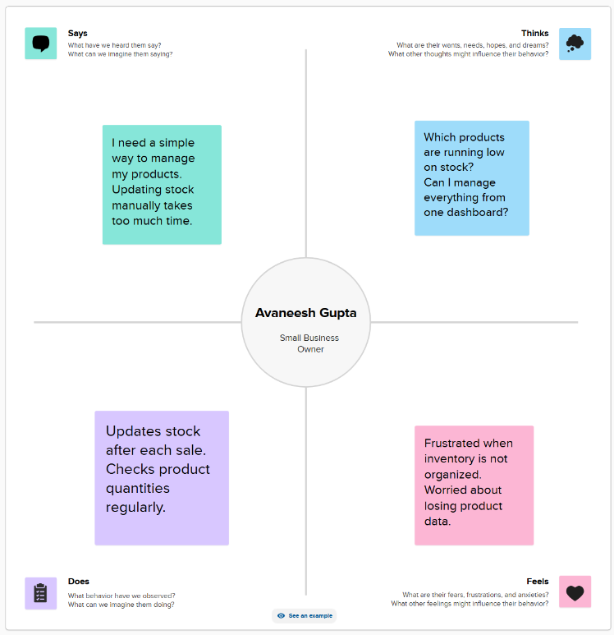

Empathy Map Example: Avaneesh Gupta
Role: Small Business Owner
- Says: "I require an easier method to organize my products. Manual stock updates consume too much of my time."
- Thinks: "What items are currently low in stock? Is it possible to control everything from a single dashboard?"
- Does: "Adjusts stock levels following every transaction. Consistently monitors product quantities."
- Feels: "Annoyed when the inventory lacks organization. Anxious about the potential loss of product data."
Would you like me to make any further adjustments, or perhaps brainstorm a second persona for your inventory management project?

